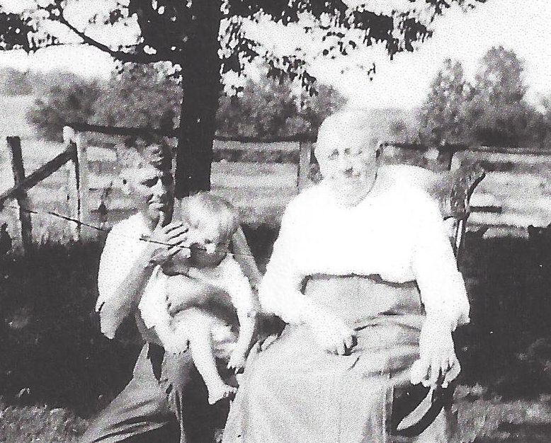

**Earl Russell Wolfe holding his son Roger Earl Wolfe**

**with his mother, Clara Bunn Wolfe – about 1923 (est.)**

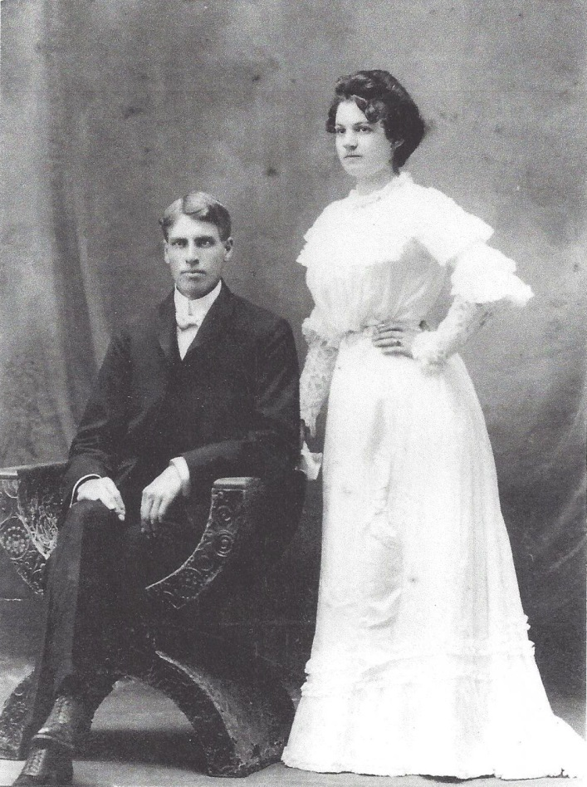

**Earl Russell and Josephine Sybil Worthen Wolfe**

**1 October, 1902, Josephine’s 18th Birthday**